OFFICE OF THE NATIONAL COMMANDER
CIVIL AIR PATROL
UNITED STATES AIR FORCE AUXILIARY
MAXWELL AIR FORCE BASE, ALABAMA 36112-5937
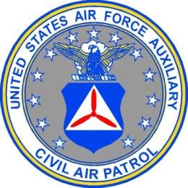

4 August 2020

MEMORANDUM FOR ALL CAP UNIT COMMANDERS

FROM: CAP/CC

SUBJECT: Interim Change Letter – CAPR 35-5, CAP Officer and NCO Appointments and Promotions

1. This interim change letter changes CAPR 35-5, CAP Officer and NCO Appointments and Promotions, dated 22 November 2016, with the implementation of the new senior member Education and Training Program. This interim change letter will remain in effect until the regulation is revised.

2. All references to “Level I” as minimum eligibility criteria for promotion are changed to read “Level I and Part 1 of Level II.” The following paragraphs are also changed to read as shown below:

1.4. Initial Grades. All members will be enrolled as CAP members without grade, unless they are specifically exempt from Level I and Part 1 of Level II of the Senior Member Education and Training Program and immediately qualify for an officer grade in consideration of previous CAP experience, as set forth in section 3.

1.6.3. Complete Level I and Part 1 of Level II of the Senior Member Education and Training program. Former members who have completed Level I training and have less than a two-year membership break are not required to retake Level I.
  - Former CAP Cadets. Upon reaching age 21, former CAP cadets who reached certain levels of achievement in the CAP cadet program are eligible for appointment to the officer grades outlined in figure 5. (See figure 11 for grades authorized former cadets under age 21).

3. Any questions can be directed to Ms. Susie Parker at sparker@capnhq.gov.

MARK E. SMITH
Major General, CAP
National Commander

